Ideation Phase
Brainstorm & Idea Prioritization Template

Date | 31 March 2026
Team ID | SWTID-2026-5494
Project Name | Automating Employee Data
Maximum Marks | 4 Marks

Brainstorm & Idea Prioritization Template:
Brainstorming is a creative technique used by teams to generate a wide range of ideas for solving a problem. It encourages open discussion, free thinking, and collaboration among team members. In this process, all ideas are welcomed without criticism, allowing participants to think innovatively and suggest both practical and out-of-the-box solutions.
The main goal of brainstorming is to focus on quantity over quality in the initial stage. This helps in exploring multiple perspectives and uncovering unique solutions that might not emerge in a restrictive environment. Team members build upon each other’s ideas, leading to more refined and effective concepts .
Reference: https://www.mural.co/templates/brainstorm-and-idea-prioritization

Step-1: Team Gathering, Collaboration and Select the Problem Statement
Our team conducted a collaborative brainstorming session where all members actively shared ideas and discussed real-world challenges in incident management systems.
After discussion, we identified the key problem:
Problem Statement:
Manual entry of employee data in ServiceNow leads to errors, data inconsistency, and increased administrative workload. Additionally, lack of real-time access to related user information (such as department and manager) slows down incident resolution.
The team agreed to focus on automating employee data integration and improving data accessibility within the system.

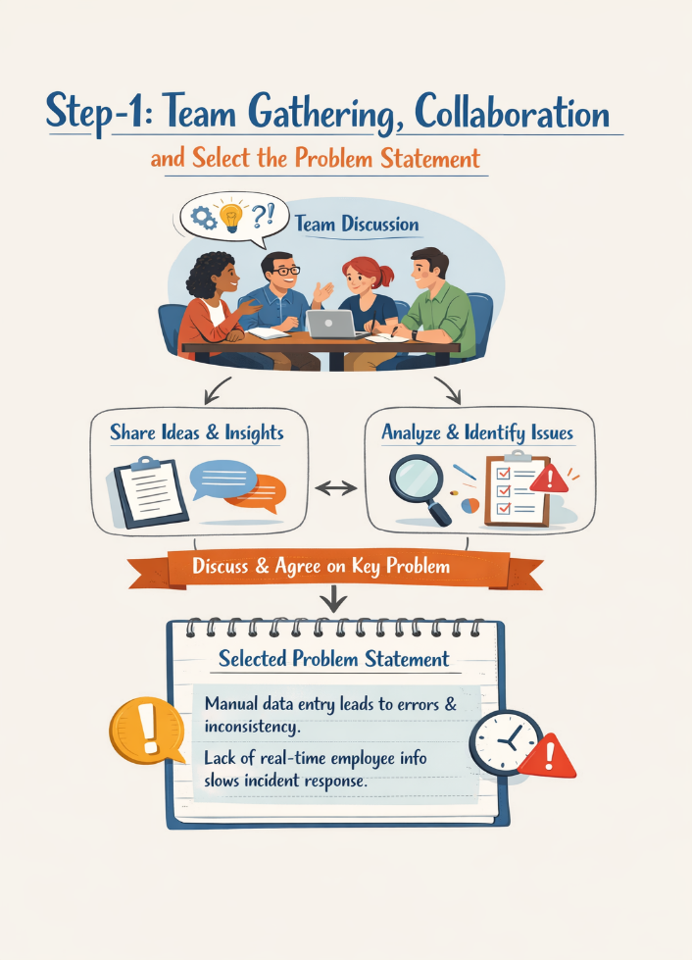

Step-2: Brainstorm, Idea Listing and Grouping .
During brainstorming, the team generated multiple ideas:

Ideas Generated:

• Automate employee data import from external sources .
• Use Import Sets and Transform Maps for data integration .
• Enable dot walking for accessing related records .
• Improve incident form with additional user details .
• Customize priority levels based on business needs .
• Reduce data duplication across tables .
Grouping of Ideas:

- Data Integration

- Import Sets
- Transform Maps
- External data sources

2. Data Accessibility
- Dot walking
- Display related fields (manager, department)

3. System Customization
- Dictionary Override
- Priority customization

4. Process Automation
- Workflow improvements
- Reduced manual effort

Step-3: Idea Prioritization

The team prioritized ideas based on feasibility, impact, and implementation ease.

High Priority Ideas:

- Automating employee data import using Import Sets and Transform Maps

- Implementing dot walking for real-time data access

- Using Dictionary Override for priority customization
Medium Priority Ideas:

- Enhancing incident forms with additional fields

- Workflow automation for incidents

Low Priority Ideas:

- Advanced analytics and reporting (can be implemented later)
Final Selected Solution:

Develop a system that integrates external employee data into ServiceNow, enables real-time data access using dot walking, and customizes incident priority using Dictionary Override to improve efficiency and accuracy.

